Editing guidelines for Authors ‒ Acta Universitatis Sapientiae, Alimentaria Series
F. Author¹ S. Author²
e-mail: firstauthor@rsdlink.ro e-mail: secondauthor@rsdlink.ro
T. Author^{1,2,*}
e-mail: thirdauthor@rsdlink.ro
¹ Sapientia Hungarian University of Transylvania,
Faculty of Economics, Socio-Human Sciences and Engineering,
Department of Food Science, RO-530104 Miercurea Ciuc, 1 Libertății Sq.
² Sapientia Hungarian University of Transylvania,
Faculty of Economics, Socio-Human Sciences and Engineering,
Department of Food Science, RO-530104 Miercurea Ciuc, 1 Libertății Sq.

Abstract. The paper should be submitted both in Word (.doc or .docx) and .pdf format. The submitted .pdf document will be used as a reference. The camera ready journal will be edited in .pdf format by the editors. An accurate formatting is required in order to reduce subsequent changes of aspect to a minimum. The pages should be set to A4 size (210 x 297 mm) with the following margin-settings: top margin to 45 mm, bottom margin to 65 mm, left margin to 35 mm and right margin to 50 mm. The paper should contain an abstract not exceeding 200 words or 15 rows.

Keywords and phrases: max. 6 words, do not include words from title
1. Introduction
Only papers written in English will be published in the journal (please use English spelling check). The paper should be formatted in a single column, including figures, tables and references.
The text should be written with Times New Roman fonts, the font sizes being specified in Table 1. The paragraph settings should be the following: alignment – justified, line spacing – single, before 0 pt, after 0 pt, and use 5 mm for first line indentation. The title of the paper, the authors’ names, authors’ affiliation, section titles, figures and tables captions, tables and equations are exceptions, they should be centered and separated by empty lines. The requirements referring those paragraphs are listed in Table 1.
Table 1. Font sizes and appearance of paragraphs
Size in points | Times New Roman | Appearance
16 | Title | Centered, bold,  spacing – before 12 pt, after 12 pt
14 | Authors’ Names | Centered;  First name: initials only, last name: only the first letter in capital;  use center tab between authors’ names;  spacing – before 0 pt, after 0 pt
10 | Authors’ e-mail address | Centered relative to authors’ name, spacing – before 0 pt, after 10 pt
10 | Affiliations | Centered,  spacing – before 0 pt, after 0 pt
10 | Abstract and  Keywords and phrases | Justified,  indentation – left 5 mm, right 5 mm;  spacing – before 0 pt, after 0 pt
11 | Main text | Justified, first line 5 mm,  indentation – left 0 mm, right 0 mm
12 | Headings | Left alignment, bold, numbered,  spacing – before 18 pt, after 10 pt
11 | Section title | Left alignment, bold,  spacing – before 12 pt, after 10 pt
11 | Section subheadings | Left alignment, italic,  spacing – before 12 pt, after 10 pt
11 | Table captions | Centered, above the table,  spacing – before 12 pt, after 6 pt
11 | Figure captions | Centered, below the figure,  spacing – before 6 pt, after 12 pt
11 | Equations | Justified, first line 5 mm,  spacing – before 6 pt, after 6 pt
10 | References | Justified, special hanging by 8 mm,  spacing – before 0 pt, after 6 pt

2. Materials and methods
The manuscript should have the following sections and headings: Abstract, Keywords and phrases, Introduction, Materials and methods, Results and discussion, Conclusions, Acknowledgements (optional), and References.
Please provide a clear description of the methods used and add statistical description if applicable.
3. Results and discussions
A. Figures and tables
Figures should be numbered and inserted in the text. Captions should be placed under figures, as shown in Figure 1. For figures, use the same type of fonts as in the main text. Please select the font size so that the text appearing within the inserted figure corresponds with a size of about 9 points.

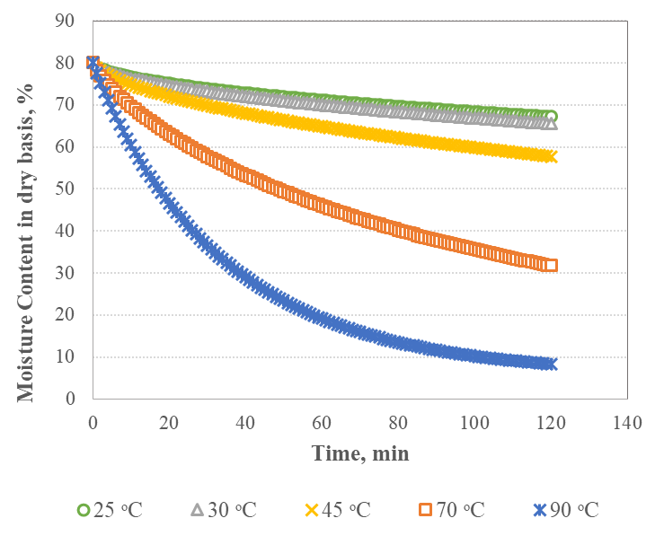
Figure 1. The effect of drying air temperature on changes in moisture content
Tables should be numbered, too. Table captions should be placed above the table. The font style and size used inside the table should be as in the main text, and the header rows should be in bold. If necessary, notes or markup explanations should be placed in a separate line under the table, the font size being 10 pt.
B. Equations
Formulas should be numbered in round brackets. The brackets should be placed to the right of the formula, finished at 12.5 cm (right tab position). For example, see below equation (1):
where: ‒ the initial sample weight, g; ‒ the final weight of the sample (when no further moisture removal was recorded at a particular drying temperature), g.
Physical quantities written with Latin alphabet (like ) in the main text should be typed in italics. The units should be written in regular letters.
C. References
References should be prepared according to the Publication Manual of the American Psychological Association (APA, 6th edition). This means that when citing references in the text, put the corresponding reference authors’ last name and the publication year in round brackets, the authors’ name should be typed in italics, e.g. (Andreani, 2017). If there are two authors of the reference paper, between their names use the “&” symbol, e.g. (Rode & Kung, 1996). If there are more than two authors, use the “et al.” abbreviation, e.g. (Csapó et al., 2018). When citing more than one publication at one place, separate them with a semicolon, e.g. (Andreani, 2017; Csapó et al., 2018).
The last section of the article has to be the References, which should be formatted as follows: justified, special hanging by 8 mm, line spacing – before 0 pt, after 6 pt.
The complete reference list should appear alphabetically by name at the end of the paper. The reference list should be numbered, too. Put the numbers in square brackets. Please follow the examples provided in the corresponding section. If there are more than five authors, use only the corresponding authors’ name and the “et al.” abbreviation.
4. Conclusions
The paper edited on the basis of the above guidelines has to be submitted electronically to the journal: acta-alim@acta.sapientia.ro and, alternatively, to the e-mail address of the executive editor: gyorgyeva@uni.sapientia.ro.
Acknowledgements
Publishing of this journal is supported by the Sapientia Foundation - Institute for Scientific Research.
Thank you for submitting your work in our journal.
References
- Andreani, N., Fasolato, L., Pseudomonas and related Genera. In: Bevilacqua, A., Corbo, M., Sinigaglia, M. (eds.), The microbiological quality of food. Amsterdam: Woodhead Publishing. (2017).
- Cone, J. E., Del Rio, M. R., Davis, J. N., Stadtman, T. C., Chemical characterization of the selenoprotein component of clostridial glycine reductase: Identification of selenocysteine as the organoselenium moiety. National Academy of Science of the United States of America. (1976) 2659–2663.
- Csapó, J., Albert, C., Csapóné Kiss, Z., Funkcionális élelmiszerek [Functional foods]. Cluj-Napoca: Scientia Publishing House. (2016).
- Csapó, J., Albert, C., Lóki, K., Csapóné Kiss, Z., Separation and determination of the amino acids by ion-exchange column chromatography applying postcolumn derivatization. Acta Universitaties Sapientiae, Alimentaria, 1. (2008) 5–30.
- EFSA, The European Union summary report on antimicrobial resistance in zoonotic and indicator bacteria from humans, animals and food in 2016. EFSA Journal, 16. 2. (2018) 5182–5183.
- Németh, C. et al., Effect of high-pressure treatment on liquid whole egg. High Pressure Research, 32. (2012) 330–336.
- Olsen, N., Miller, J., Storage management options for disease control. University of Idaho. https://www.uidaho.edu/-/media/UIdahoResponsive/Files/cals/programs/​potatoes/Storage/storage-mangement-options-for-disease-control-05.pdf (undated)
- ***The Editors of Encyclopaedia Britannica, Encyclopedia Britannica: "Cowpea", 23 Jun. 2022. Available on-line: https://www.britannica.com/plant/​cowpea. Accessed 21 December 2022.

